Attached is the drawing.

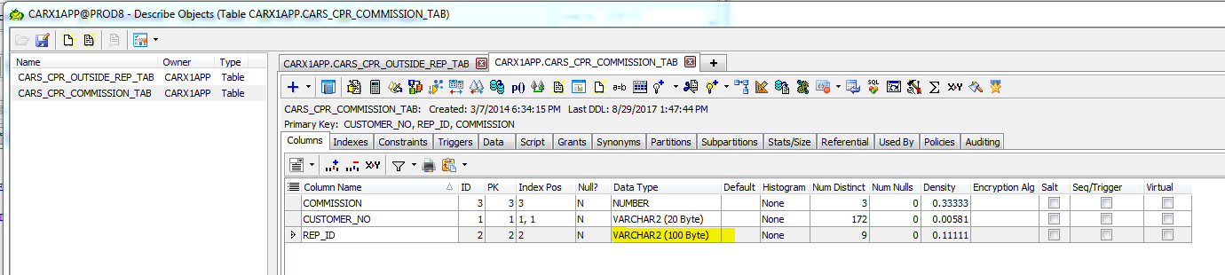

select customer_no, count(customer_no) count_customer, commission from CARS_CPR_COMMISSION_TAB

group by customer_no, commission

having count(customer_no) > 1

create table CARS_CPR_OUTSIDE_REP_TAB   AS (select distinct outside_rep from CARS_CPR_COMMISSION_TAB)

CREATE VIEW CARX1APP.CARS_CPR_COMMISSION  AS

(

SELECT cprt.customer_no,

       carx1app.customer_info_api.get_name(cprt.customer_no) cust_name,

       cpro.outside_rep,

       cprt.commission

 FROM  cars_cpr_commission_tab cprt,

       cars_cpr_outside_rep_tab cpro

WHERE  cprt.rep_id = cpro.rep_id

)

UPDATE CARS_CPR_COMMISSION_TAB B

SET (REP_ID) = ((SELECT REP_id FROM CARS_CPR_OUTSIDE_REP_TAB A

                 WHERE B.REP_ID = A.OUTSIDE_REP ))

WHERE exIST

select * from cars_cpr_commission

SELECT * FROM  CARX1APP.CARS_CPR_OUTSIDE_REP

SELECT CUSTOMER_ID,NAME FROM CUSTOMER_INFO

WHERE

SELECT * FROM CARS_CPR_OUTSIDE_REP_TAB